
DISCOVER THE CELESTIAL BEAUTY OF LUNA

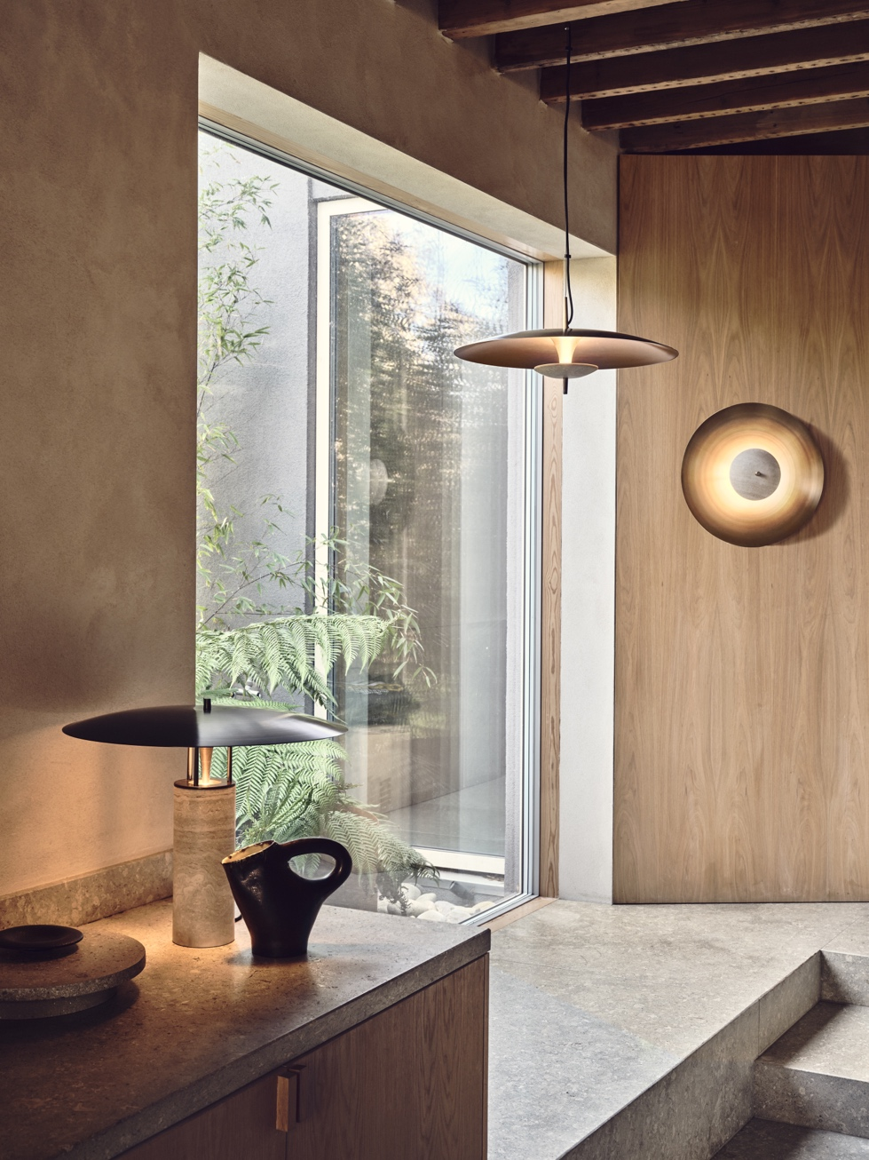

Experience the timeless elegance and meticulous craftsmanship of the Luna lighting collection.

Named after the Roman goddess of the moon, the Luna lighting collection from J. Adams & Co. combines luminous brushed brass with a choice of luxurious stone finishes, including black marble, travertine, and red marble. Each material is steeped in sculptural and architectural history, adding a touch of timeless elegance to any space.
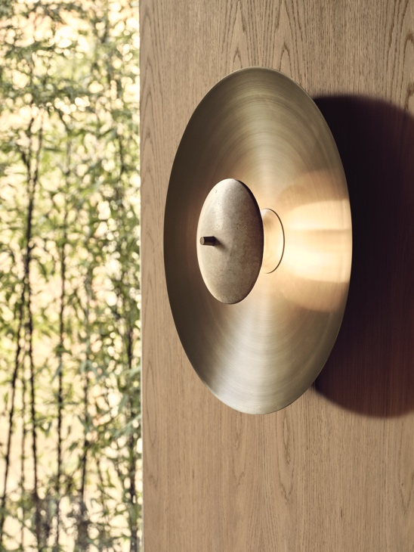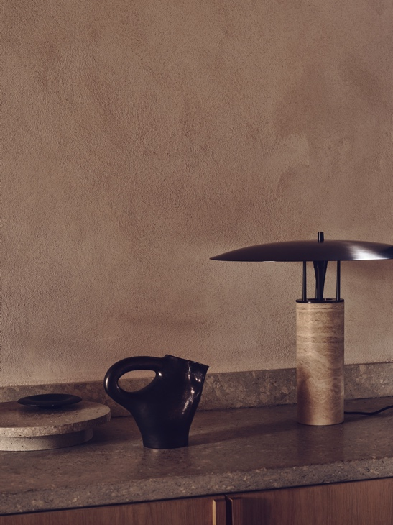

Exploring concealed light and reflected illumination, Luna takes inspiration from the cosmos, mimicking the effect of a total eclipse by using natural stone discs to obscure its LED light source. The light is then reflected by a large hand-spun brass dish, casting an outward halo of warm and inviting indirect light.

The hand-spun brass dish is a testament to meticulous craftsmanship, expertly created in the J. Adams & Co. workshop. Each dish is shaped using traditional hand-spinning techniques, which involves carefully spinning a flat brass disc on a lathe while applying precise pressure with specialised tools. This labour-intensive process gradually creates the distinctive curved form that beautifully reflects the light.



Including a pendant and wall light, available in three sizes, and table lamp in brushed
brass and bronze options; Luna is engineered by design director Will Earl and handcrafted
in the brand’s UK workshop. A collection of sculptural centrepiece luminaires
which balance functionality with aesthetics, Luna effortlessly transforms the ambience
of any interior space with uncompromising and contemporary mid-century style.

For high resolution imagery, videos, quotes and product loans, please contact press@jadamsandco.com

Notes to Editors:
J. Adams & Co is a British lighting manufacturer that specialises in elegant luminaires of unparalleled quality. Handmade in the UK, their Birmingham factory has over half a century of manufacturing and metalworking expertise. The brand seamlessly melds traditional techniques with a nuanced, modern sensibility, focusing on craftsmanship and longevity. The result: refined and contemporary lighting that is built to last.



